MAST Academy Yoga Club and 7th Grade Civics Classes
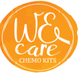
Will be collecting “We Care Chemo Kits”

We Care Chemo Kits is designed to brighten up a cancer patient’s day in the darkest moment of their life. The items listed below are for the children chemo kits. Choose at least 5 items from the list – every bit helps! We thank you for your contribution! Follow these 5 easy steps:
Children Chemo Kits
1. Decide if you are shopping for a boy or girl.
2. Choose the age category: 2-4 years old / 5-9 years old / 10-14 years old / 15-18 years old.
3. Visit your local dollar/craft/novelty store and purchase the items listed below (keep your age category in mind when you are shopping).
4. Staple a note outside the bag listing the gender and age you selected.
5. Drop off in one of the participating classrooms. Sign that you have dropped off the items, scan the QR code and fill out the Microsoft form to receive 2 hours of community service.
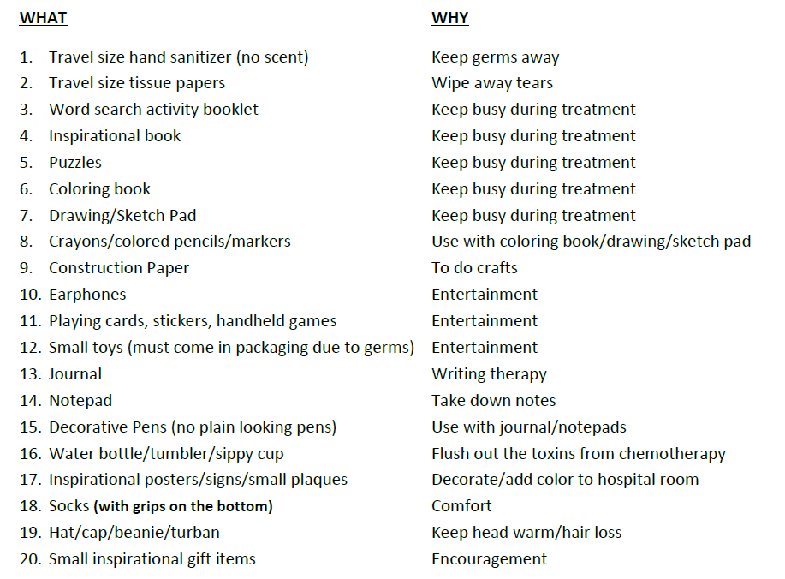
Additional items allowed: Superhero/Disney characters/Barbie/child-appropriate items welcomed.
*NO lotion, candy, fresh flowers, stuffed animals, hygiene products or food donations are allowed.


